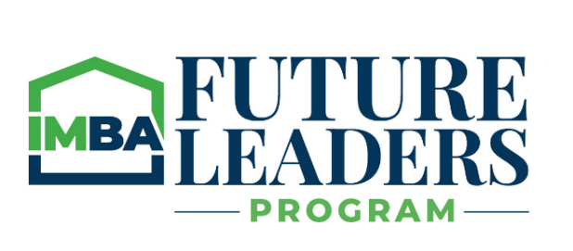

IMBA Future Leaders Application – Fall 2023

Please complete the information below and forward it, along with a recommendation letter from your supervisor, senior management or IMBA member sponsor (current or past member of IMBA State Board) to rteare@indiana.bank, or mail to:

Personal:
IMBA
Attn: Ross Teare
8425 Woodfield Crossing Blvd, Ste 155E, Indianapolis, IN 46240

First Name MI Last Name

Company Position/Title

Work Address

Phone # Email address

Home address (Class binder and graduation plaque mailings)

Work History/Experience: (attach current resume)

Years of experience in industry and with current employer? /

Questions:

  - Why are you interested in this program?

  - To date, what has been your greatest accomplishment within mortgage banking?

  - Outside of your job, what activities have you been involved with in regard to volunteer activities that you are most proud of?

  - What do you want to get out of this program as a result of your successful completion of all 9 modules?

  - What is the biggest obstacle or challenge you are dealing with currently?

Recommendation(s)

Attach a recommendation letter from your supervisor and/or senior level manager at your company explaining why he/she feels you deserve serious consideration for this program.

Upon receipt of the application, the IMBA will contact you to confirm receipt, and follow up shortly after for any questions concerning the course.

All students accepted into this program agree to attend each session and proactively participate within each session. Students may have pre- and post-class assignments to complete and turn in based upon instructor. Also, each student will be asked to participate in committees at their local chapter or at the state level.

